Join us for a Meet & Greet
Ramsey and Washington County

Wednesday, April 24, 2019
6:00 - 8:00 p.m.
St. Paul Labor Center
353 West Seventh Street, Saint Paul

Engage with your local elected officials and let them know what issues are
IMPORTANT to you! This is a great opportunity to hear directly from
the decision makers as they grapple with the issues that shape our future.

Representative Ami Wazlawik, 38B |  | Representative Tou Xiong, 53A
Representative Shelly Christenson, 39B |  | Representative Steve Sandell, 53B
Senator Carolyn Laine, 41 |  | Representative Anne Claflin,54A
Representative Mary Kunesh-Podein, 41B |  | Representative Kaohly Her, 64A
Representative Kelly Moller, 42A |  | Representative Dave Pinto, 64B
Representative Jamie Becker-Finn, 42B |  | Representative Rena Moran, 65A
Senator Charles Wiger, 43 |  | Representative Alice Hausman, 66A
Representative Peter Fischer, 43A |  | Representative John Lesch, 66B
Representative Leon Lillie, 43B |  | Representative Tim Mahoney, 67A
Senator Susan Kent, 53 |  | Representative Jay Xiong, 67B

and more

Refreshments will be provided. To RSVP or if you have a question, please contact
Colleen Nocerini at 612-408-2412 or cnocerini@stpaulunions.org

Sponsored by Ramsey and Washington County’s Labor Assemblies

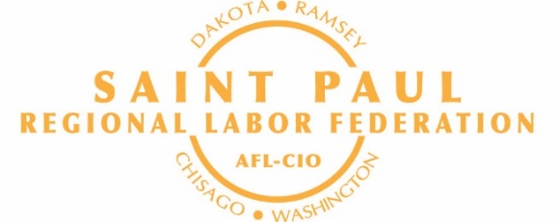

Opeiutc#12lt

