Thursday, April 18, 2019
5:00 p.m. – 8:00 p.m.
North Saint Paul/Maplewood/Oakdale
School Referendum
St. Paul Labor Center
353 West Seventh Street, St. Paul

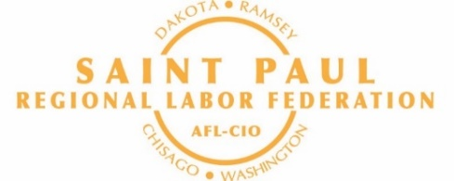

Please RSVP to: Colleen Nocerini at 612-408-2412
or cnocerini@stpaulunions.org

Opeiutc#12lt

